FLIGHT RESERVATION PROJECT
The Flight Reservation System is a web-based application designed to simplify the process of booking, managing, and cancelling flight tickets. The system maintains a database of flights, users, and bookings to ensure efficient data handling and retrieval. It includes features such as user authentication, seat availability tracking, booking tickets etc. The project is developed using technologies like a backend server, database management system, and a user-friendly interface. Overall, it improves accuracy, reduces manual effort, and enhances the user experience in airline reservation processes.
QURIES
CREATE DATABASE
USE
CREATE TABLE PASSENGER
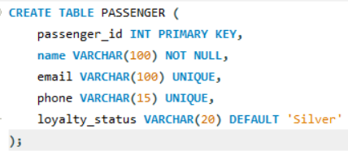
CREATE TABLE ROUTE
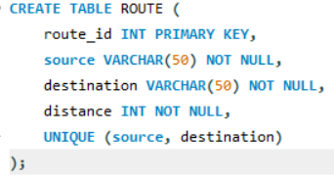
CREATE TABLE FLIGHT
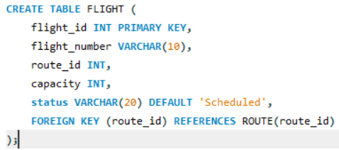
CREATE TABLE SCHEDULE
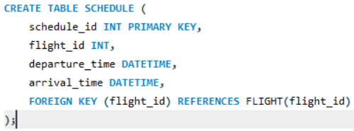
CREATE TABLE SEAT
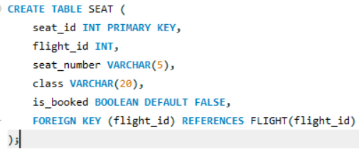
CREATE TABLE BOOKING
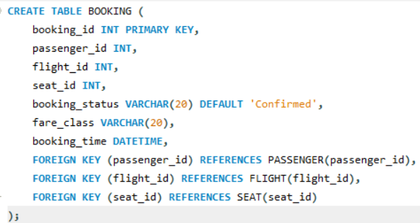

CREATE TABLE PAYMENT
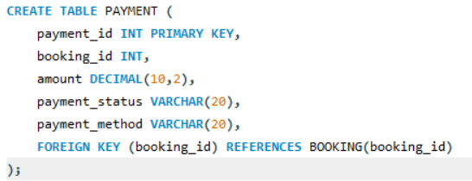
INSERT VALUES PASSENGER
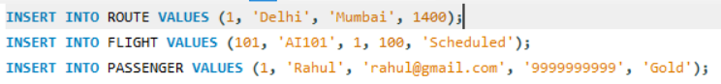
SEAT AVAILABILITY
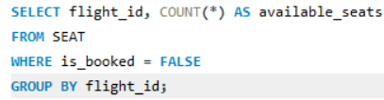
BOOKING STATUS
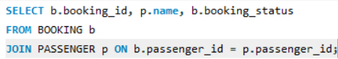
FLIGHT CANCELLATION
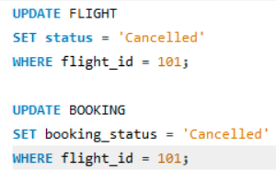

CHECK OVERBOOKING
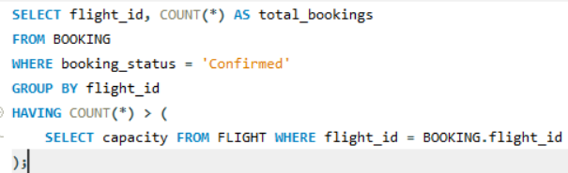
WAITING LIST
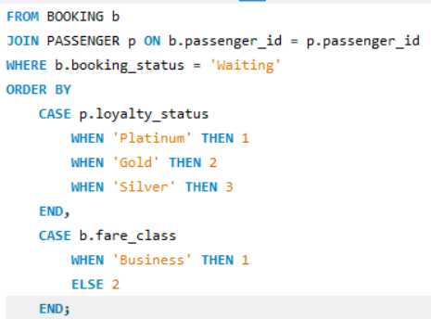
UPDATE LOYALTY
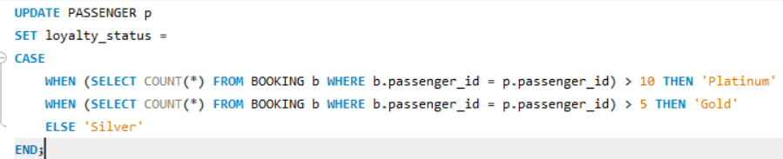
JOIN QURIES
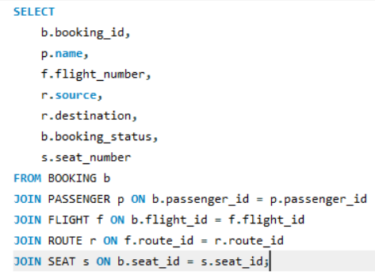
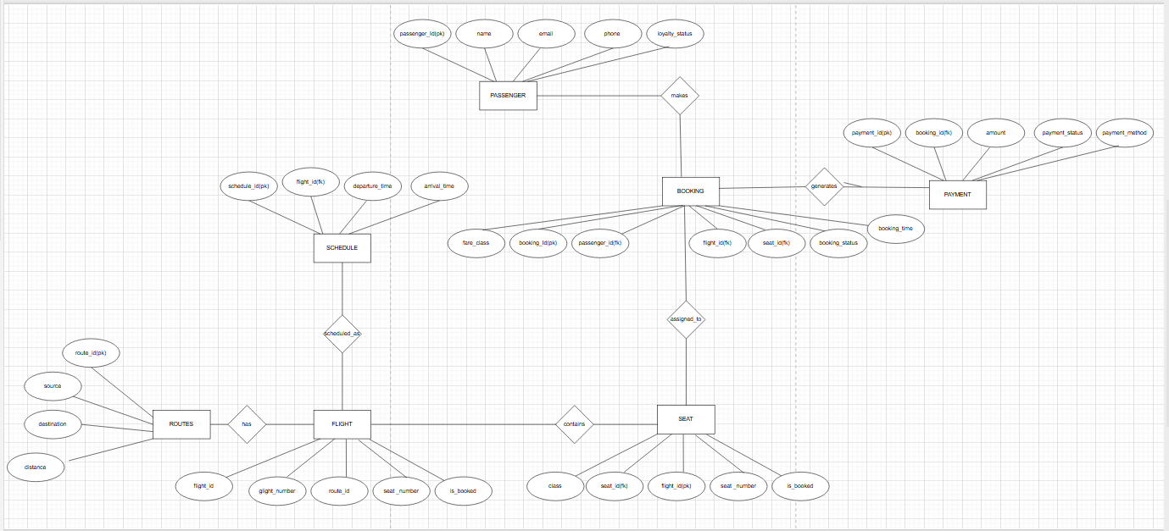
ER DIAGRAM

Entity | Attributes | Primary Key | Foreign Keys
PASSENGER | passenger_id, name, email, phone, loyalty_status | passenger_id | -
ROUTE | route_id,source,destination, distance | route_id | -
FLIGHT | flight_id, flight_number, route_id, capacity, status | flight_id | route_id → ROUTE
SCHEDULES | schedule_id, flight_id, departure_time, arrival_time | schedule_id | flight_id → FLIGHT
SEAT | seat_id, flight_id, seat_number, class, is_booked | seat_id | flight_id → FLIGHT
BOOKING | booking_id, passenger_id, flight_id, seat_id, booking_status, fare_class, booking_time | booking_id | passenger_id → PASSENGER  flight_id → FLIGHT  seat_id → SEAT
PAYMENT | payment_id, booking_id, amount, payment_status, payment_method | payment_id | booking_id → BOOKING

Relationship | Entities Involved | Type | Description
Has | ROUTE → FLIGHT | 1 :M | One route can have many flights
Scheduled As | FLIGHT → SCHEDULE | 1 :M | One flight can have multiple schedules
Contains | FLIGHT → SEAT | 1 :M | One flight has many seats
Makes | PASSENGER → BOOKING | 1 :M | One passenger can make many bookings
Has Booking | FLIGHT → BOOKING | 1 :M | One flight can have many bookings
Assigned To | SEAT → BOOKING | 1 : 1 | One seat assigned per booking
Generates | BOOKING → PAYMENT | 1 : 1 | One booking has one payment

